COMP1715 Scholarly and Academic Practice

Academic Paper

The Internet of Things in a Wider Urban Context

University of Greenwich

Usman Basharat

000874782

**Abstract**

Technology has changed the world drastically. Hence, why Internet of Things is the future of technology. In this report, it explores how Internet of Things is going to run as expected in the near future. This discusses the legal, ethical, logical, social, environmental, and profession issues about this topic.

**Introduction**

**Is it going to all change?**

Internet of Things (IoT) is a physical object that contains an internet-based system that can be controlled remotely. International Data Corporation is a telecommunication organisation that does an analysis on technology globally. They help make decisions to enhance technology. According to the Senior Vice-President of Research of IDC Vernon Turner, he feels, “The Internet of Things will give IT managers a lot to think about. Enterprises will have to address every IT discipline to effectively balance the deluge of data from devices that are connected to the corporate network.” IDC predicts that Internet of Things can be introduced by 2020 and they feel that it could be a huge asset towards any organisation (Hudges, 2014).

It seems ridiculous, but one example could be by reducing your heating temperature when you need before you enter your own home. However, having physical objects that are controlled remotely in a place of residence can have security issues. On the other hand, Internet of Things can revolutionise the perspective of the healthcare system, home facilities, transportation and retail stores (Abigail, 2015). Many different features can come into play in the next five years. Technology is rapidly increasing much of its developing innovation would enhance everything by making daily routines easier for consumers.

By 2020, it is estimated that 50 billion objects connected to the internet (Strickland, 2015). The daily lifestyle routine will improve drastically.

*How it will work?*

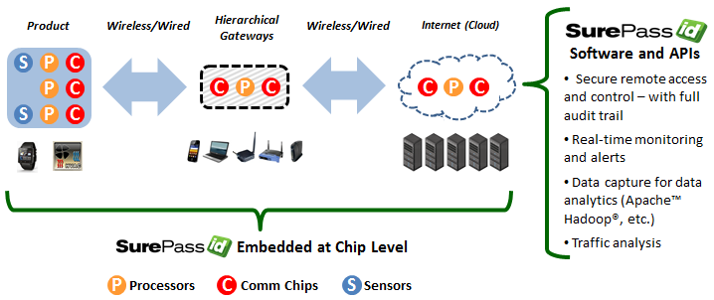Each category of the IoT will run differently. For example, sensors will be different depending on what is needed. For example, once the temperature sensor is activated, this could be the presence of the person; it connects to the internet wirelessly and automatically predicts what the user requires. Imagine you walk into your own room, with your latest mobile phone; a sensor will detect the current date through your phone. Once this is complete, it will check the current weather allowing the temperature of the room to be warmer, or cooler. This will be all linked to any other devices to execute the temperature being cooler, or warmer. It predicts by using specific algorithms that will be made so precise that it predicts what any person needs. Having different types of sensors would enable different products, or services, to work differently. Referring to Figure 1.1, it summaries it all.

Figure 1.1

Cloud computing is in, which large groups of servers are grouped together to allow others for a use of service. Clouds can be classified as public, private or hybrid. Internet of Things will be looking to use Cloud storage to store data. An example of cloud storage can be Microsoft SkyDrive – data can be stored privately on this application.

**IoT effecting these sectors:**

1. **Home**
2. **Healthcare**
3. **Transportation**
4. **Cities**

*Timeline*

4G is the current generation of telecommunication. As we all know, lots of data is expected to be transferred and the data to be handled. As expected, *5G* is the next major generation to improve the current one. This runs at a rate of 1TB per second.

Internet Protocol is a unique numbers to identify each computer. As the population and technology keeps on growing, it enables more computers to be released and run. The current internet protocol version is IPv4. IPv4 is the current version of the internet Protocol. *IPv4* is a 32-bit and they are running out of IPs. IPv4 is worth 232 = 4,294,967,296 addresses. An example of IPv4 is 156.15.259.3. As we, all want Internet to be fast, the population keeps growing; therefore, more IPs are needed.

Therefore, *IPv6* is going to be released in 2020 and this is going to be 128 bits.

Referring to Figure 1.2, it demonstrates the timeline of what to expect from the technology to come. This picture was released from 2014, therefore it predicts what to expect from then. However, you can see that Internet of Things is highlighted to be reached within 5 to 10 years. Many more advanced technologies is shown below on the timeline too.

[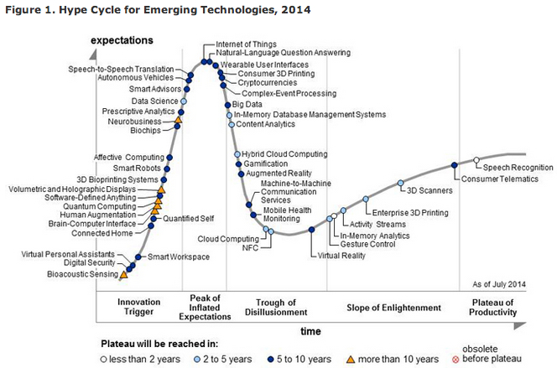](https://www.google.co.uk/url?sa=i&rct=j&q=&esrc=s&source=images&cd=&cad=rja&uact=8&ved=0CAcQjRxqFQoTCLid9YKehMkCFcQvDwodYU8LDQ&url=http://www.geekwire.com/2014/internet-things-wearables-3d-printing-chart-shows-hyped-technologies-2014/&bvm=bv.106923889,d.ZWU&psig=AFQjCNGRNUHP61O9Wwwvejx2ql0z6DM_YA&ust=1447189194759021)

Figure 1.2 Expecting what technology to get from more than 10 years. Year predicted at 2014.

Referring to (Goldman Sachs, 2014), it is predicted that 28 billion devices can be connected to the internet. A case study shows that it leads a breakthrough figure of numbers by saving 55 million kWh of electricity. However leading to the cost of the whole project, it will cost this $7.1 trillion by 2020 (Sulleyman A, 2014). A question could be raised whether deprived countries and areas would be supported with these emerging technologies. However, those potential countries that become rich can invest in this huge project enabling their country to be cost effective. People with a financial crisis cannot benefit with the technologies. This shows that the cost of the project leads to how it will take and how big the project is leading to changing the way we all live.

Social

Evidently, it is clear that technology makes human lifestyle easier to live. On the other hand, some of the technology might not appeal well of the elderly and disability.

Toddlers have clear issues with modern day technology that it has come to a stage of addiction. Referring to (Ward V, 2013), experts have given a strict warning that usage of iPads and iPhones can produce damaging long-term effects. “Children have access to the internet almost from birth now”, this demonstrates that the mass increase in technology could cause serious illnesses, or injuries. Some of those include eyesight problems, neck injuries, back pain, addiction and causing some teenagers to become angrier. The future of technology is enhancing and this would attract more toddlers and young-aged teenagers to become addicted of using the Internet. Becoming addicted to the internet enables users to prolong their sociable activities to a later stage. Furthermore, most teenagers use social networking sites enabling them to go through an emotional trauma. Emotional disasters could lead to risk of teenagers being suicidal.

The culture of each person that they go with is different. Consider the following scenario: if any person were to buy an Indian takeaway only for one day, the person would receive emails based on the action and behaviour of the person. It only predicts what the user may want depending on what they need. It may predict something wrong. For example, if it is all new and I came back from work late, it would assume that I need some relaxing music to relax. However, the change there is that I want something of my taste. Some IoT sensors need to get use to each person being different and adapting to the cultural or atmospheric needs.

Introducing Internet of Things, it may raise some following questions:

**Why would you want to adapt to a society that exposes risks?**

**Can we avoid all of this?**

**Why change?**

**Is there any long-term effects for Internet of Things?**

**How do we learn this?**

Security

Security may be at a huge risk even when Internet of Things emerge. The USA Government has invested security in over $13 billion in 2010. These figures may have doubled by now. This shows that the government cares about the security of data. However, if the current stage is at that point, more security issues can be evolved. As mentioned above, 28 billion devices are at a stage of vulnerability. Even though the top priority is security of the whole project, it seems even more likely that the exposure of privacy can be exposed easily. If security is at risk at this point, how is security going to be maintained at 2020? If a rough figure of $13 billion is spent on only security and the number of device usage is 10 times bigger; the number of money spent could increase by 10 times too. Of course, when the new data is arrived, mistakes are made within it. If someone does something for them not too, they can get in trouble. Furthermore, if hackers get access to one user’s details, the hacker can access to all of the information of the users. Therefore, he can bribe the user to do things they do not want to do. Things are already in place, and without thinking, it shows that security threats are a bigger concern. This will get more complicated and hard to maintain. More legislation needs to be in place in order for security to be in place.

*Data Protection Act*

Vast amounts of data is processed as millions, or even trillions, of data being transferred. Top priorities should be held with security and privacy. This act was introduced in the 1998s for any organisation that deals with information that transfers data, which needs to be lawfully processed. This law was set as this is vital information was to prevent any data being exposed. For example if a user’s information were to be hacked and expose, it would embarrass their privacy. A life insurance company had insurance on the user’s information and it reveals news that he or she did not want to reveal; it would enable the life insurance not to insure on the person’s life.

*It seems as though security is at a top of the list even for customers. Therefore, when accessing any IoT element, or device, a solution could be the only way they can access it is by using the owner’s fingerprints.*

*Everyone knows that keeping a strong password prevents emails being hacked easily. However, by raising this, it would enable users not to keep an easy password that someone can guess.*

**Government**

**Cost Effective**

<http://www.gsma.com/newsroom/wp-content/uploads/15625-Connected-Living-Report.pdf>

**Conclusion**

**References**

Cha, B. (2015). A Beginner's Guide to Understanding the Internet of Things. [Online] Re/code. Available at: http://recode.net/2015/01/15/a-beginners-guide-to-understanding-the-internet-of-things/ [Accessed 30 Oct. 2015].

DaCosta, F. (2013). Rethinking the Internet of Things. [New York, N.Y.]: ApressOpen.

Goldman Sachs, (2015). *The Internet of Things: Making sense of the next mega-trend*. [Online] Available at: http://www.goldmansachs.com/our-thinking/outlook/internet-of-things/iot-report.pdf [Accessed 12 Nov. 2015].

Gubbi, Jayavardhana, (2013). "Internet of Things (IoT): A vision, architectural elements, and future directions." Future Generation Computer Systems 29.7 [Accessed 29 Oct. 2015]

Hype Cycle, (2014). *Hype Cycle for Emerging Technology*. [Image] Available at: http://cdn.geekwire.com/wp-content/uploads/2014/08/hypecycle444.jpg [Accessed 5 Nov. 2015].

Niewolny, D. (2013). How the Internet of Things Is Revolutionizing Healthcare. 1st ed. [eBook] Available at: http://cache.freescale.com/files/corporate/doc/white_paper/IOTREVHEALCARWP.pdf [Accessed 30 Oct. 2015].

Roberto, I.Belda, (2014). Internet of Things: Advantages May Far Outweigh Its Drawbacks. Available at: http://guardianlv.com/2014/01/internet-of-things-advantages-may-far-outweigh-its-drawbacks/ [Accessed on 16 Oct 2015]

Sulleyman, A. (2014). *IDC predicts an IoT riot: Internet of Things market to be worth £4 trillion by 2020 | ITProPortal.com*. [Online] ITProPortal. Available at: http://www.itproportal.com/2014/06/06/internet-of-things-to-be-worth-trillions-consumers-and-businesses-thirsty-for-a-taste/ [Accessed 10 Nov. 2015].

Understanding the Internet of Things (IoT). (2014). first ed. [eBook] Available at: http://www.gsma.com/connectedliving/wp-content/uploads/2014/08/cl_iot_wp_07_14.pdf [Accessed 2 Nov. 2015].

VJ Nair, L. (2015). Security aspect of internet of things. [Online] MSys. Available at: http://msystechnologies.com/blog/2015/05/21/the-security-aspect-of-the-internet-of-things/ [Accessed 30 Oct. 2015].

Ward, V. (2013). *Toddlers becoming so addicted to iPads they require therapy*. [Online] Telegraph.co.uk. Available at: http://www.telegraph.co.uk/technology/10008707/Toddlers-becoming-so-addicted-to-iPads-they-require-therapy.html [Accessed 4 Nov. 2015].

Zanella, A., Bui, N., Castellani, A., Vangelista, L. and Zorzi, M. (2014). Internet of Things for Smart Cities. IEEE Internet of Things Journal, 1(1), pp.22-32.